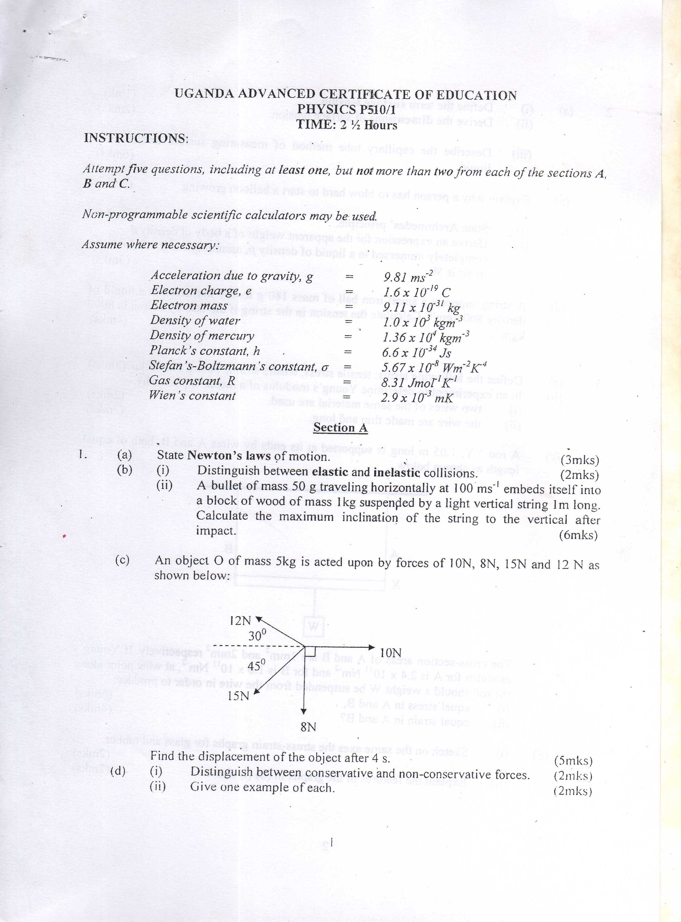

**MOCK EXAMINATIONS 2016**

